Unit Test Plan

SOX

# 1 Table of Contents

1 Table of Contents i

1.1 Document Versions ii

1.2 Related Documents ii

*2* Overview 3

3 Assumptions, Interdependencies 3

3.1 Assumptions 3

3.2 Test Plan Summary 4

4 Execution and Actual Results 5

**4.1** **Defects** 5

## Document Versions

|  |  |  |  |
| --- | --- | --- | --- |
| Version | Date | Author | Notes |
| 1 | 05/14/2025 | Anzla Sharma | Initial Version |
|  |  |  |  |
|  |  |  |  |

## Related Documents

|  |  |  |
| --- | --- | --- |
| Version | Date | Related Documents |
|  |  |  |
|  |  |  |
|  |  |  |

# Overview

To cater client’s requirement, new BO audit algorithms need to be developed and applied on BO to track application-level changes on usage and VEE rules. Apart from that, audit must be enabled on all the linked tables mentioned below to track any changes on Database level. As per client’s requirement, we will also create report on EDMS to track changes occurring due to package deployment. A OAC report must be created for the to extract the data from audit tables.

# Assumptions, Interdependencies

## Assumptions

* NA

# Test Plan Summary

|  |  |  |  |
| --- | --- | --- | --- |
| **Seq** | **Test Condition Description** | **Expected Result** | **Passed (**Y or N) |
| 1 | To Check if audit is performed on usage calculation rule | Audit performed | Y |
| 2 | To Check if audit is performed on VEE rule | Audit performed | Y |

# Execution and Actual Results

## **Defects**

### Usage Rules

#### 4.1.1.1 UR-CHK-MISS-INT-KWH-CONS

##### 4.1.1.1.1 Field Value Change

###### 4.1.1.1.1 BO algorithm

###### 4.1.1.1.2 Before

###### 4.1.1.1.3 After

###### 4.1.1.1.4 DB Results

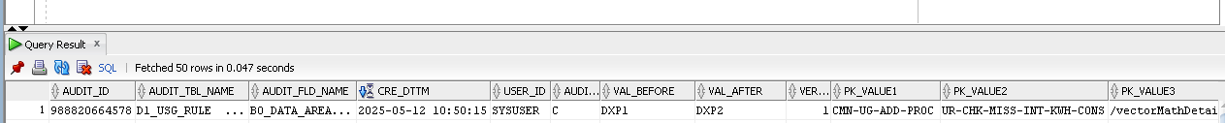

##### 4.1.1.1.2 List Value Chagne

###### 4.1.1. 2.1 BO algorithm

###### 4.1.1. 2.2 Before

###### 4.1.1. 2.4 DB Results

#### 4.1.1.2 UR-EXE-BASE-ALIGN-DT

##### 4.1.1.1.1 Field Value Change

##### 4.1.1.2.1 BO algorithm

##### 4.1.1.2.2 Before

##### 4.1.1.2.3 After

##### 4.1.1.2.4 DB Results



##### 4.1.1.1.1.2 List Value Chagne

Bo algo:

Befor:

After:

Db:



### VEE Rules

#### 4.2.1.1 INT-SPIKE-CHK

##### 4.2.1.1.1 BO algorithm

##### 4.2.1.1.2 Before

##### 4.2.1.1.3 After

##### 4.2.1.1.4 DB Results



#### 4.2.1.2 NEG-CONS-CHK

##### 4.2.1.2.1 BO algorithm

##### 4.2.1.2.2 Before

##### 4.2.1.2.3 After

##### 4.2.1.2.4 DB Results

